After decompression, launch the sample via OPC_DEMO.exe.

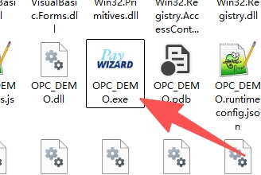

In Serial mode (corresponds to OPC SERIAL HOST/SLAVE/EXT mode): Select the corresponding serial port from the Port dropdown and then click "Open" to connect the serial port.
In Socket mode (corresponds to OPC SOCKET SERVER mode): In the Host field, enter the local IP address of the POS machine, and then click "Connect" to connect to the OPC.
- Connect to the OPC application via Serial/Socket.
- Select the desired TransType, enter the amount and other parameters, then click ‘Send’ to initiate the transaction.
- Click 'Cancel' to cancel the currently executing transaction.

Serial port screenshot:
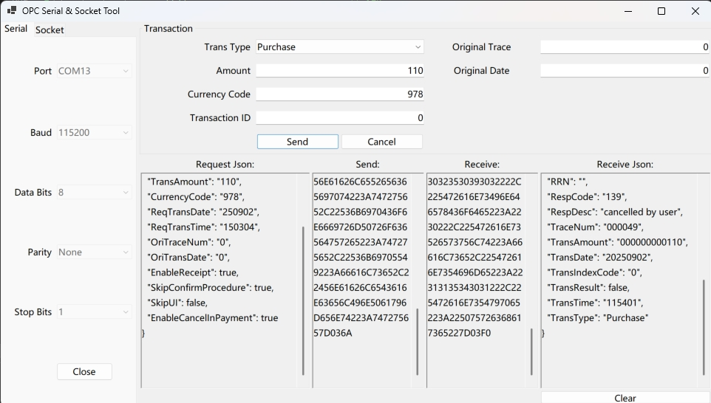

Socket screenshot：
