Emulator testing method

**Preparing the Test Environment ：**

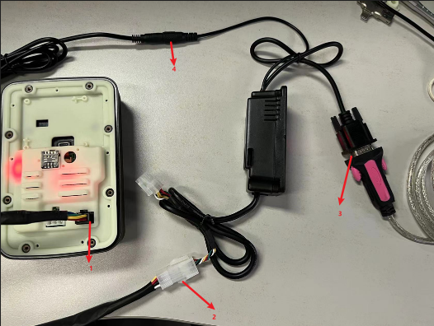

1. Connect the black connector of MDB cable to UPT;

2. Connect the other end to the simulator;

3. Use the DB9 to USB cable to connect the emulator to the computer;

4. Connect the 24V DC power adapter to the power port of the simulator;

[**test method**](javascript:;)：

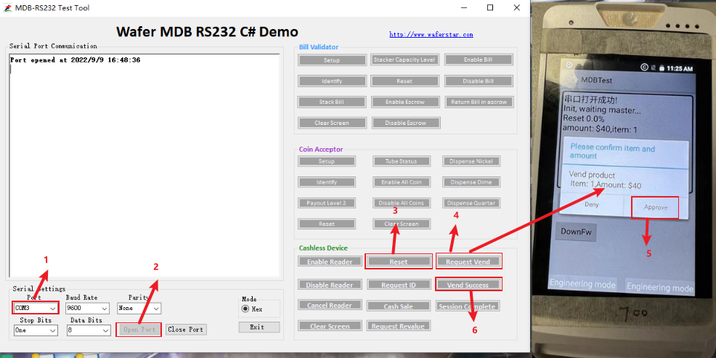

1. Select the com port on the PC software (default baud rate);
2. open the port;
3. Click [Reset] to reset the status;
4. Click [Request Vend] to place an order;
5. Confirm the prompt message on UPT and click [Approve];
6. Click [Vend succes] on the PC software.