OPC操作文档

## Open the application to enter the page, click six time in the lower left corner

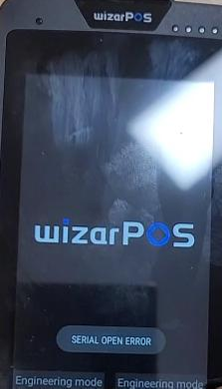

Click ADMN MENU andenter the password :99999999 to enter the next page

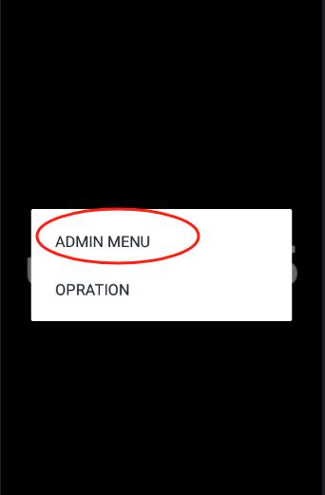

## Click SETTING

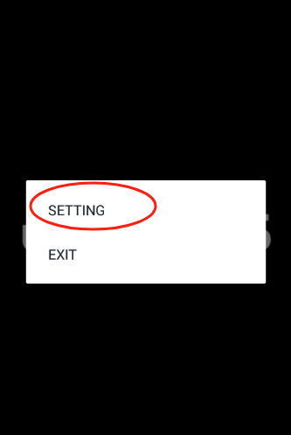

## Click [Protocol type]

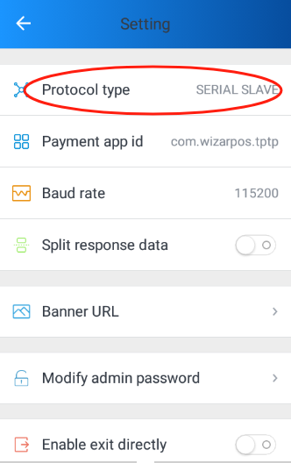

## 4. Choose correct communication mode

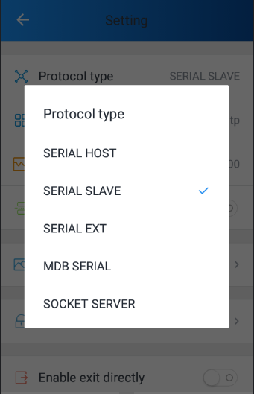

* SERIAL SLAVE: use usb cable
* SERAL HOST: use UUcable
* MDBS SERIAL: use MDB 
* SERIAL EXT: use physical serial port
* SOCKET SERVER: use network